SE 491 BIWEEKLY REPORT 5
sdmay20-25: Consumer Aware Warehouse Management
3/12/20 – 4/2/20
Team Member | Roles
Jimmy Paul  jpaul@craftydelivers.com | Client
Goce Trajcevski  gocet25@iastate.edu | Advisor
Lindsey Sleeth  lssleeth@iastate.edu | Meeting Scribe  Project Manager  Software Developer
Sam Stifter  stifter@iastate.edu | Test Engineer  Software Architect  Software Developer
Omair Ijaz  oijaz@iastate.edu | Quality Assurance Engineer  Meeting Facilitator  Software Developer
Jameel Kelley  jamkelley22@gmail.com | Report Manager  Software Architect  Software Developer
Andrew Smith  arsmith3@iastate.edu | Database Administrator  Quality Assurance Engineer  Software Developer
Elijah Buscho  elijah@iastate.edu | Test Engineer  Software Dev  Proj Manager
Devin Üner  druner@iastate.edu | Software Architect  Machine Learning Specialist

Bi-Weekly Summary

Objective
Frontend
- Display distributor information in distributor cards
- Dynamically generate distributor products for each distributor card
- Finalize connections with endpoints and display data -- meaning we will only have to substitute the URL with the algorithm data

Backend
- Create Endpoints to facilitate storing prediction data
- Create new Database tables to store prediction data
- Create Endpoints for retrieving the prediction data

Prediction Algorithm
- Integration of Algorithm with Database
- Testing Algorithm

Accomplishments
This week the frontend team completed the distributor product cards to dynamically generate and dynamically generate all of the items associated with the distributor. The backend team successfully completed the backend. This week specifically, the backend team modified the database to be able to store predictions. An endpoint was created to view these prediction tables.

Summary of Weekly Advisor Meeting
In the weekly advisor meeting, our team discussed wrapping up the project by completing the backend endpoints and getting everything finalized in connecting the components for the frontend and the backend. We still have one more iteration we can continue finalizing things, but the goal is to have everything done and to begin working on the final presentation. If there is time after all of the components are wired up, we may go back in and add a few more simple features or flesh out a plan for how this project could continue to be extended.

The original plan was to look into a couple of more algorithms and compare predictions, however, the scope has been cut down a bit with our Advisor and Client due to all of the current events.

Past Accomplishments (Individual)
Lindsey Sleeth
I worked with Jameel on connecting endpoints with the frontend to display data dynamic about distributors and their products in a card style. Now that we have connected these, connecting the endpoints with data from the algorithm should be a matter of changing the URL and making a few minor edits. A picture of what these cards look like is shown below. Each distributor is limited to showing at most 6 products on a page and then it is paginated. Some distributors do not have all of their fields and that is because that information is null in the data that we were provided by Crafty.

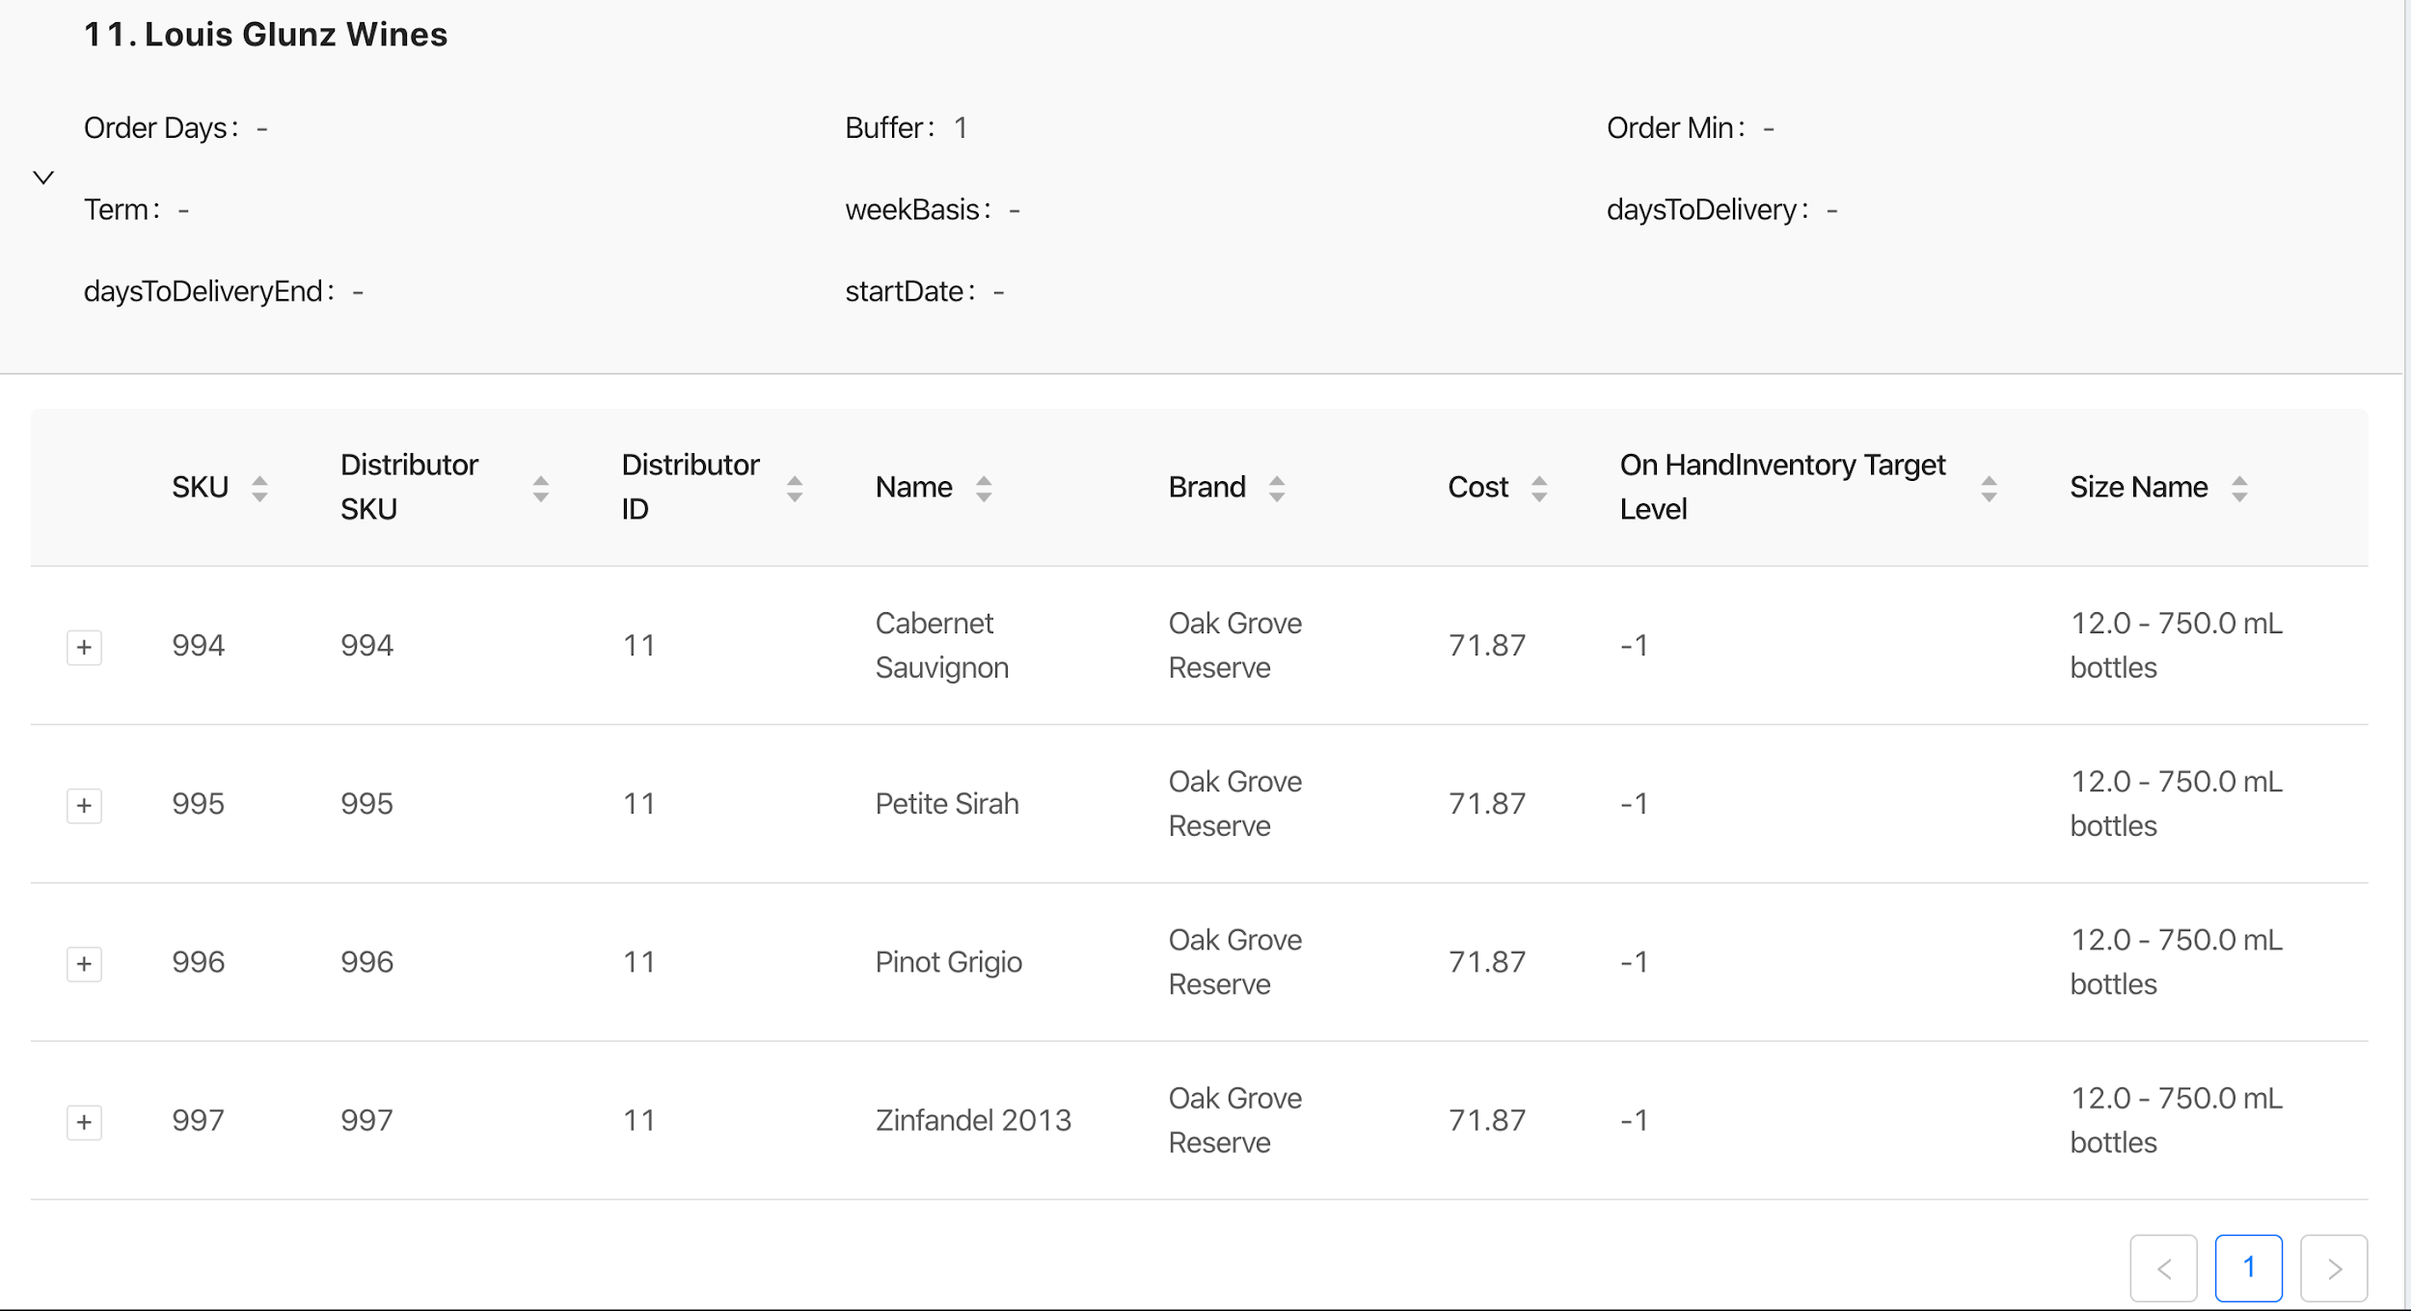
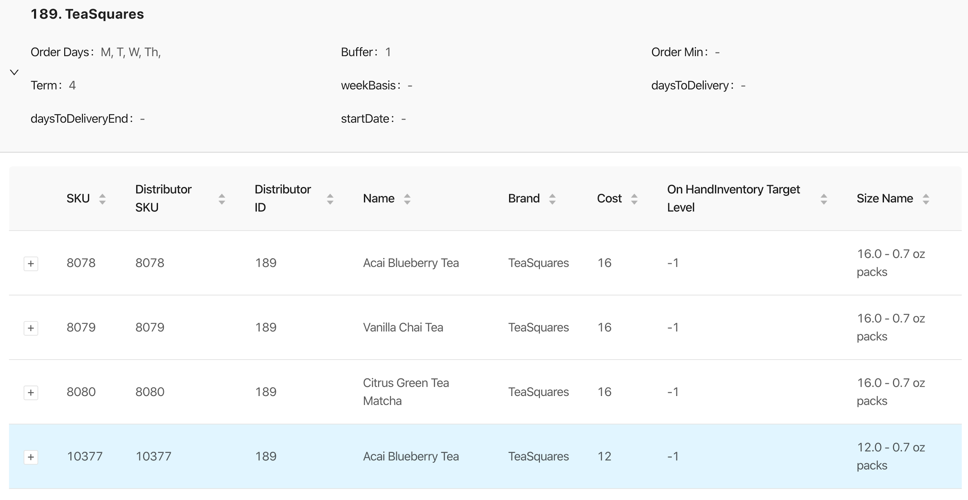
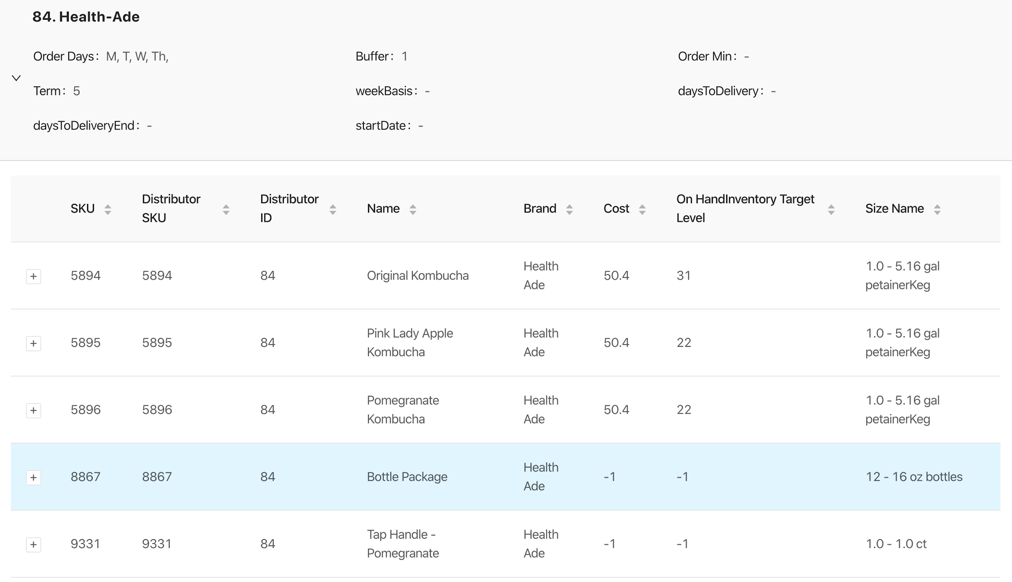

Elijah Buscho
I wrote pseudo-code for the algorithm necessary for assessing the accuracy of predictions: 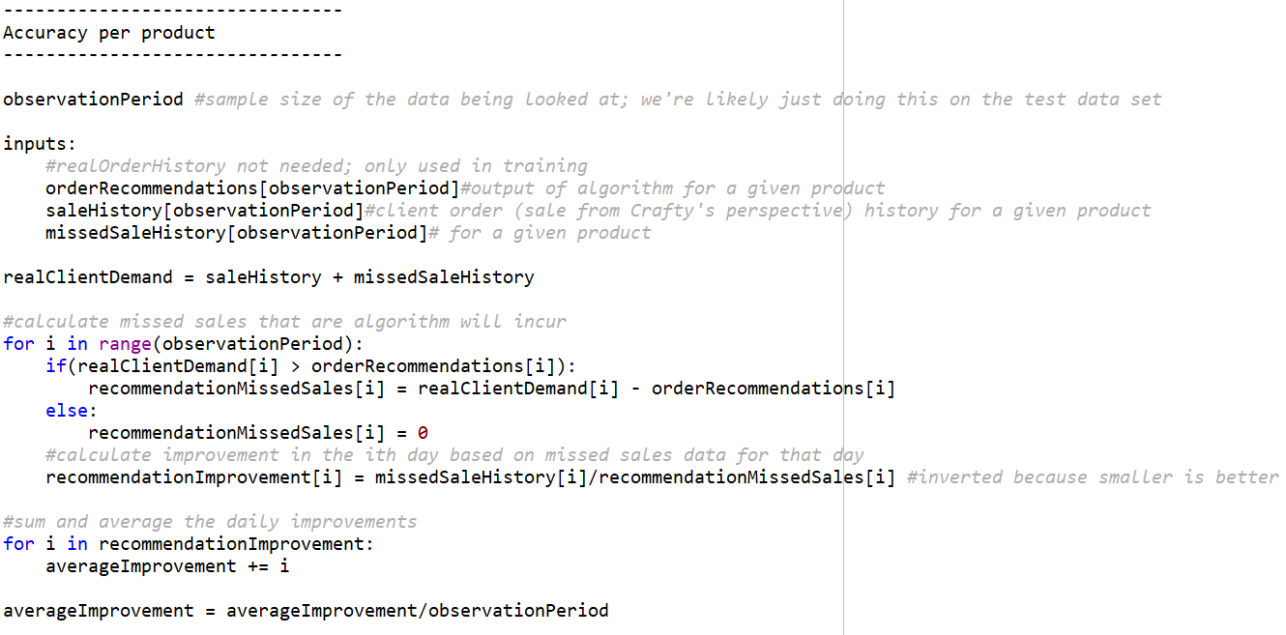
Based on this pseudo code I discussed with Andrew to make sure all of the necessary data is available for the implementation.

Jameel Kelley
This week was spent working with Lindsey on the integration of the endpoints to the frontend to display data dynamics about distributors and their products. Additionally, the React Testing Library was set up this week. This was the only setup and no relevant tests were added as of yet.

Andrew Smith
Over the past couple of weeks, I worked on adding an endpoint to accept a JSON object with predictions to store in the database. This is needed as the algorithm runs it needs to store the predictions in the database so that the frontend can pull it any time they need the data. I also worked on getting an endpoint up for pulling all the SKU predictions only showing the latest prediction for each SKU. I got that endpoint working to pull all the predictions and only send the most up-to-date prediction.
Omair Ijaz
I worked on completing my last query which shows all incoming deliveries to the warehouse. At this point, the backend team has completed all the required endpoints.
Sam Stifter
I worked with Andrew on completing the table setup for storing prediction data. My tasks related to this were to set up the POST endpoint to create a new prediction entry. Andrew and I went back and forth with the endpoints and we eventually had them all tested and implemented. We deployed it to the server and Andrew worked to get mock data in the database for early testing and integration. This will help the frontend be able to integrate the endpoint even though there isn’t real data there yet. It will also allow the algorithm to save its results for later retrieval.

Devin Üner
I worked on integration, so making the machine learning algorithm update the predictions using actual data from our server. This required connection with a few of the APIs we set up. I also researched a bit more, on some more machine learning algorithms.

Individual Contributions
Name | Individual Contributions | Hours this Period | Hours Cumulative
Lindsey Sleeth | Displaying distributor information in distributor cards | 10 | 35
Jameel Kelley | Setting up the test suite, distributor display cards | 20 | 39
Sam Stifter | Prediction Table and Endpoints | 20 | 62
Andrew Smith |  | 15 | 65
Omair Ijaz | Incoming | 10 | 54
Elijah Buscho | Testing algorithm | 10 | 51
Devin Üner | Worked on integration and researched another potential algorithm | 10 | 19

Pending Issues
Lindsey Sleeth
There are no pending issues at this time

Elijah Buscho
N/A

Jameel Kelley
No current pending issues
This week the main issue while working on the frontend was not having an endpoint for getting all the distributors extra data. This resulted in making N API requests where N is the number of distributors. This has since been resolved as the backend team has made a new endpoint to alleviate the issue.
Andrew Smith
After spending several hours trying to get this working, I messaged the backend team to help me with this as we need it ASAP so we can be finished. Sam then came in and got his version implemented and working. I also am having problems at the time of this report on getting the endpoint for predictions for all SKUs and only the latest predictions for each SKU. I have the query that would pull the correct information, I just can’t seem to get it working in an endpoint. I also noticed that when Sam created the table he made the sku_id type int when sku_id is type long so we are going to be fixing that as well.
Omair Ijaz
There are few bugs remaining on the backend. Including setting tables up and server permissions

Sam Stifter
The server is having permissions errors when we deployed the finalized endpoint. More investigation will be needed to resolve this so the new endpoints can be used.

Devin Üner
none

Upcoming Plans
Lindsey Sleeth
My plans are to modify the URLs to display data that is given to us from the algorithm and to visualize this data in a graph. Additionally, if there is time I would like to create filters to only display distributors based on certain criteria.

Elijah Buscho
The plan is to implement the testing algorithm specified in the pseudo-code.

Jameel Kelley
The test suite configuration still needs to be worked on so they run on the compilation of the code. Additionally, the .yaml Gitlab file needs to be updated to add the frontend tests to the pipeline. Also changing the API requests to the new and updated versions.
Andrew Smith
I plan on working on the presentation and poster to wrap things up for the course. I will also work on any last-minute thing we need for data and endpoints that the other teams may need last minute.
Omair Ijaz
The final task is to complete the poster and the presentation. We have looked at poster designs and are in the process of mocking our poster.
Sam Stifter
I will plan on starting the presentation and the poster to wrap up the semester. I will also be on call for any changes that need to be made if bugs are found in the configuration of the backend server.

Devin Üner
Finish integration by making predictive software use the actual data. Also, make that all parameterized so it can be updated as needed.

